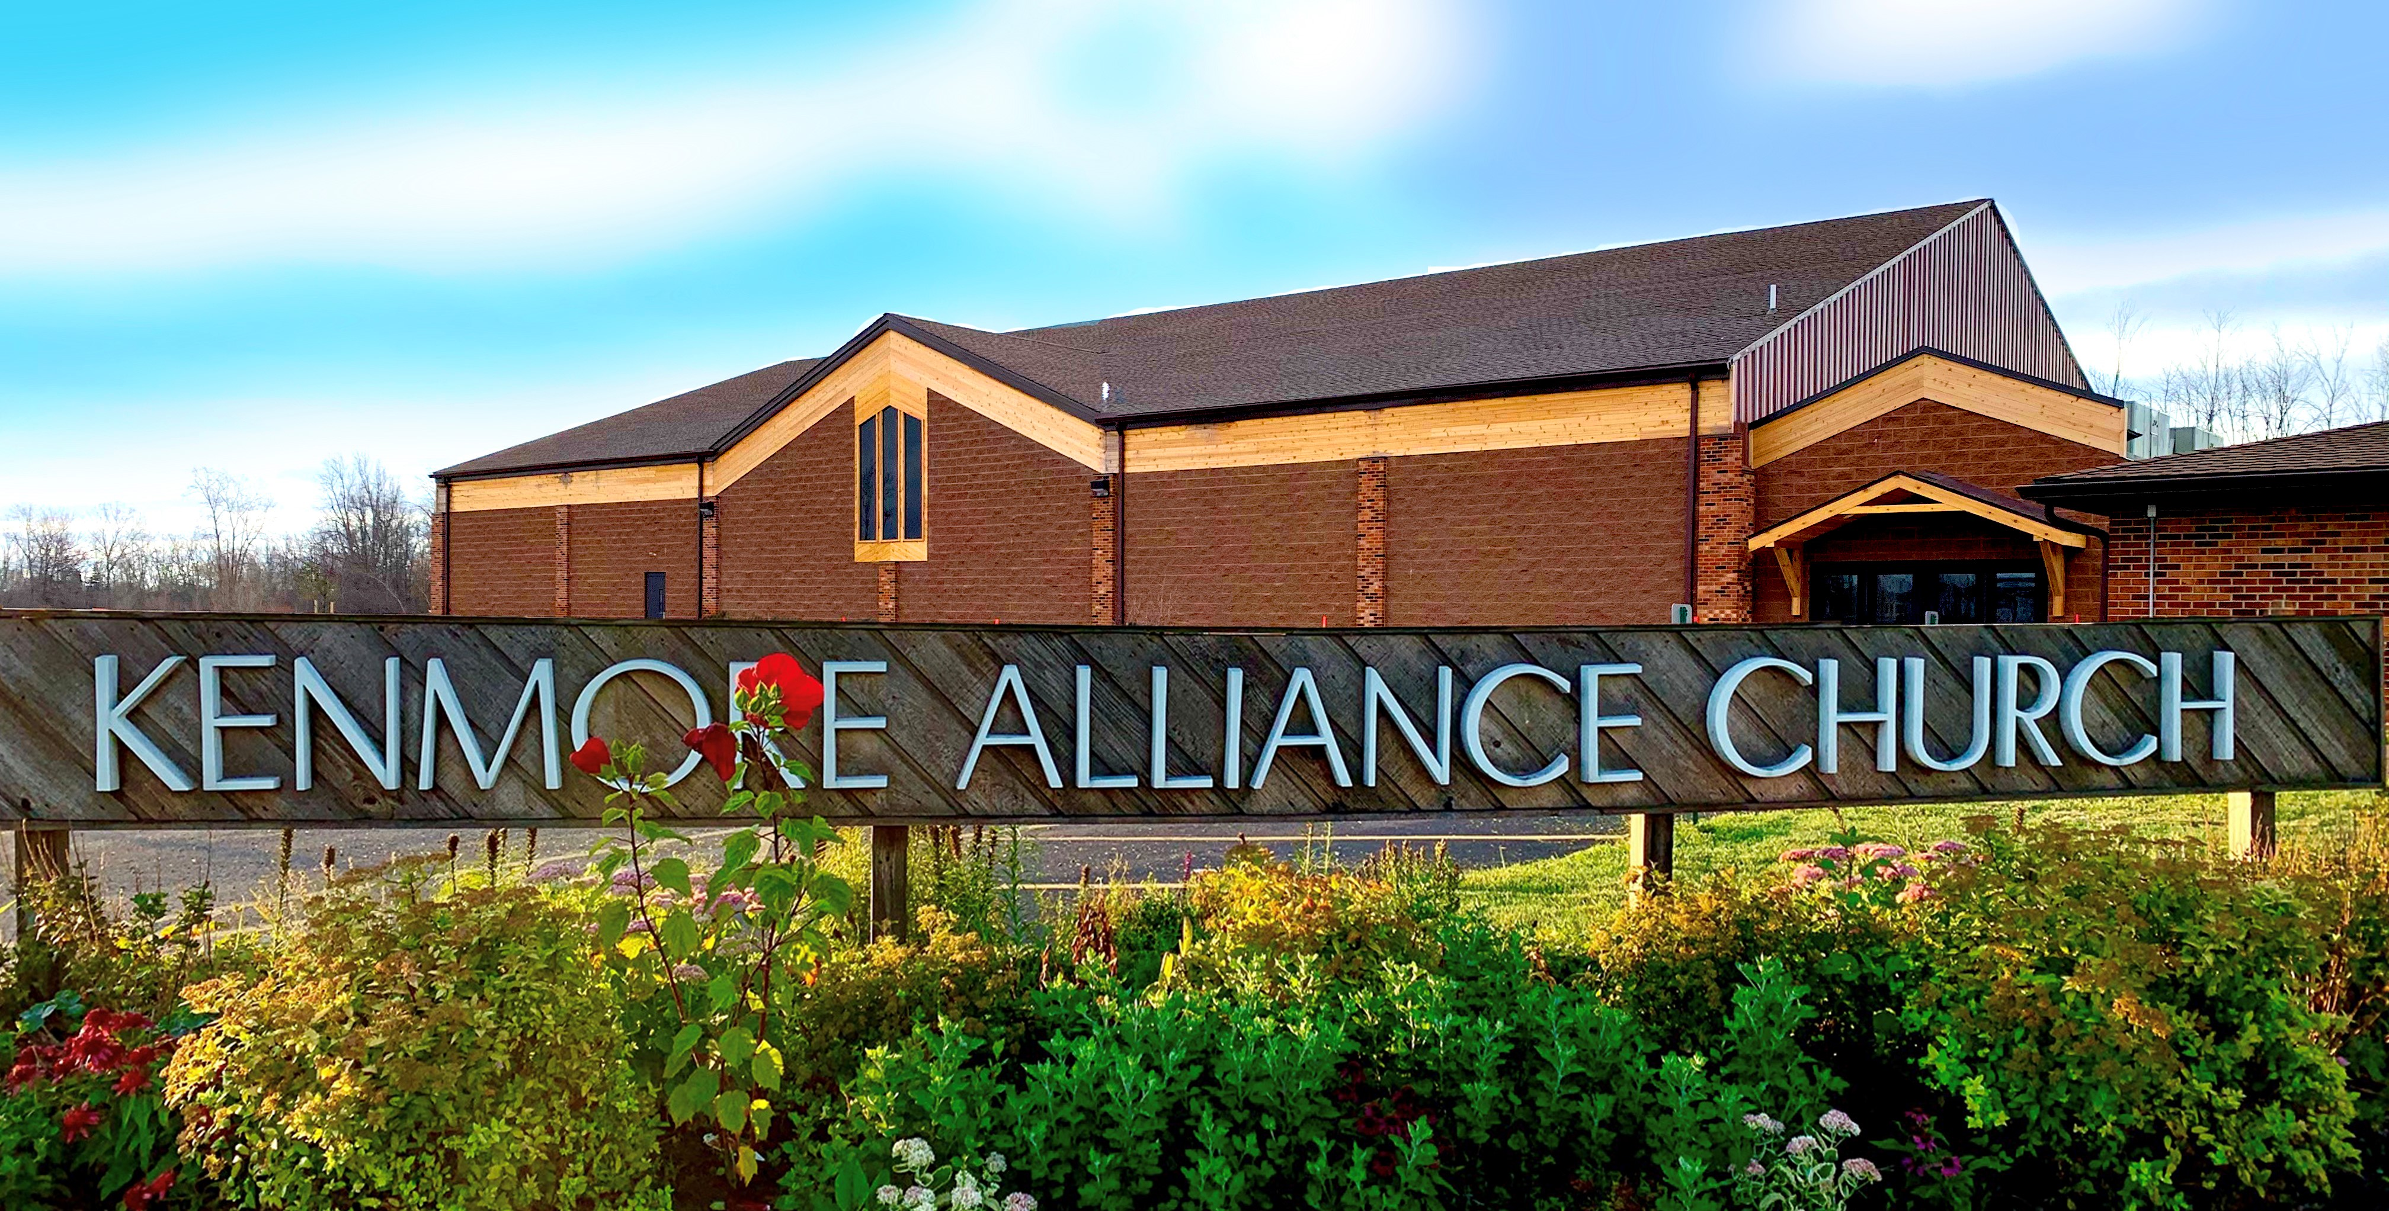


2020 ANNUAL REPORT

We exist to glorify GOD
by making disciples of Jesus Christ who make disciples . . . . .

TABLE OF CONTENTS

BOARDS FOR 2021 2
APPOINTED COMMITTEES FOR 2021 3
STAFF REPORTS ________________________________________________4-8
FACILITIES MANAGER____________________________________________9
ELDER_________________________________________________________10-12
DEACONS______________________________________________________13
DEACONESS 14
TREASURER’S REPORT _________________________________________15-17
MEMBERSHIP ROSTER_____________________________________18-19

BOARDS FOR 2021

Ministry Board Jeff Goodband, Chairman
Charles Jones, Vice-Chairman
Sherri Roy, Recording Secretary
Austin Miller, Treasurer
Jeff Camp, Assistant Treasurer
Paul Keleher, Elder Representative
Mary Lou Francoforte, Deaconess Representative
Larry Scaglione, Deacon Representative
Phil Coburn, Facilities Representative
Rebecca Henderson, Disciple-making Committee Representative
Sharon Pusateri, Member -at-large
Keith Roseboro, Member-at-large
Louis Shakkour, Member-at-large

Board of Elders Bob Oursler Adam Williams
David Barden Brian Baney
Evans Christian Paul Stark
Al Fast Charles Jones
Paul Keleher Jeff Spencer

Board of Deacons Paul Horvath Ken Swanekamp
Nick Francoforte David Wendt
Carl Bampton Gary Stanton
Joe Brown Rob Pusateri
Gerry Soto Steve Roy
Steve Westberg Larry Scaglione
Chad Heidelberger

Board of Deaconesses Karen Blain Lisa Scaglione
Tracy Keleher Maria Bampton
Gail Stark Donna Robson
MaryLou Francoforte Linda Stanton

Facility Team Dennis DeWyer Bob Barden II
Tom DeWyer Bob Barden Sr.
Rick Bostaph Junior Garcia
Phil Coburn

New York State Trustees Jeff Spencer (3 yr. term)
Bob Oursler (2 yr. term)
Brian Baney (1 yr. term)

Nominating Committee Evans Christian, Chairman
Adam Williams
Jeff Spencer

APPOINTED COMMITTEES FOR 2021

Disciple Making Ministries Committee Evans Christian, Men/Women/Chairman
Carolyn Kiddy, Children
Adam Williams, Youth
Kate Balon, Youth and Communications
Rebecca Henderson, KAC Serves

Worship Committee Katie Bergsten, Chairperson
Charles Jones
Jeff Goodband
Elizabeth Coburn
Don Weiss
Kevin Danwin

Finance Committee Austin Miller, Chairman
Jeff Camp
Minfei Leng
Sharon Pusateri
Judy Miller
Jeff Goodband

LEAD PASTOR: Charles Jones
“Yet once more I will shake not only the earth but also the heavens.” This phrase, “Yet once more,” indicates the removal of things that are shaken—that is, things that have been made—in order that the things that cannot be shaken may remain. Therefore let us be grateful for receiving a kingdom that cannot be shaken, and thus let us offer to God acceptable worship, with reverence and awe.” Hebrews 12:26-28

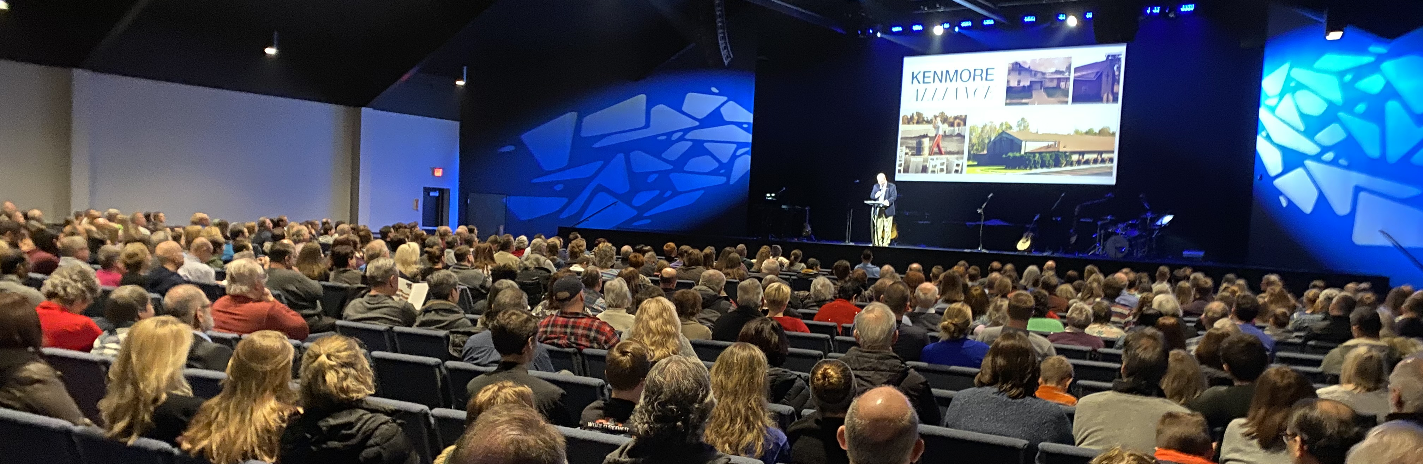
We came into 2020 with tremendous momentum as we opened our new Worship Center with a Dedication Service on February 1st and our first new worship services on March 1st. With over 800 in attendance for two weekends in a row, none of us would imagine that this new beautiful building would sit empty for the next 3 months. But God had plans to stretch us. And we are better for it.
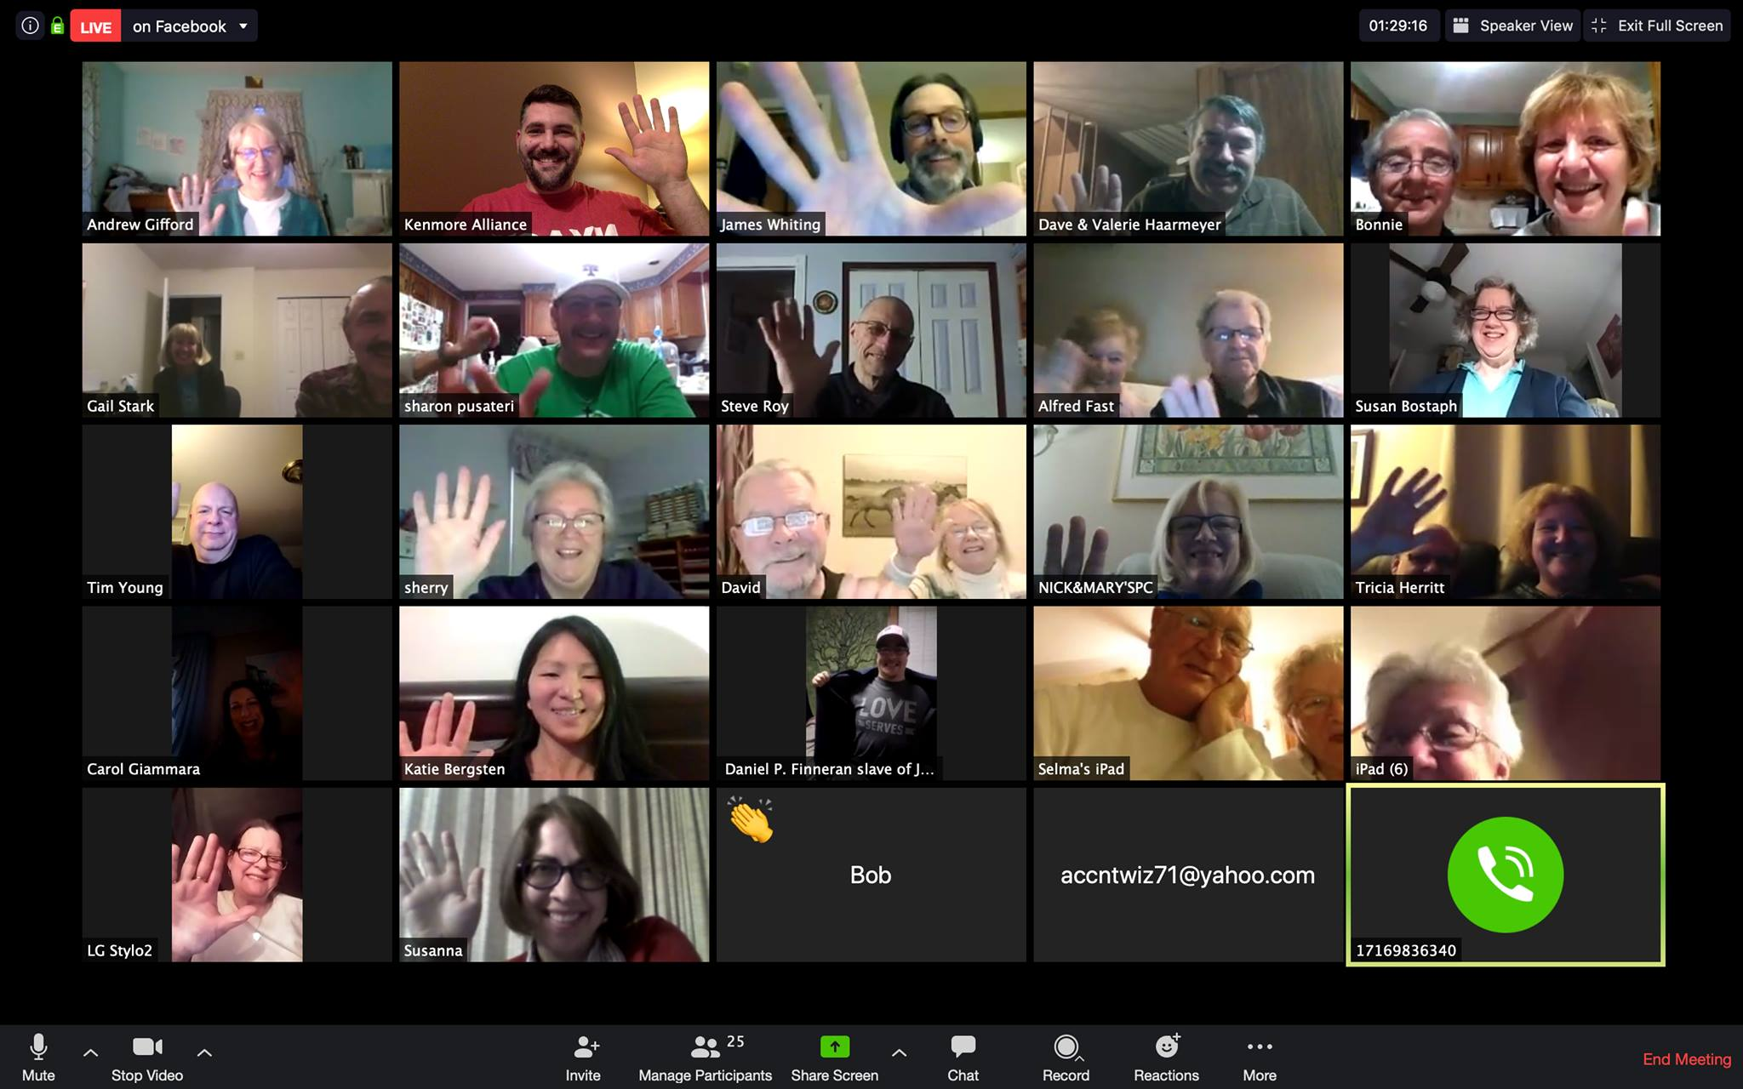
The Covid crisis hit in mid March and we canceled our services on March 15th. The cancellations continued to events, and missions trips, and conferences, and all in-person services for the next 3 months. Our giving took an immediate hit because of the circumstances, and with unemployment rates starting to climb, offerings decreasing, a mortgage payment approaching, (and toilet paper disappearing) our financial team was faced with some very hard and tough decisions. We froze spending and the staff followed suit by taking pay cuts. There were many unknowns. But we also prayerfully chose not to depend on the government for stimulus. After all, our God is an awesome God!

As the dust began to settle, and KAC proved to pivot well in this community crisis with Zoom bible studies and prayer meetings, and Virtual YouTube services, and even a new Online Giving platform, the KAC family, continued to be the Church we have always been!

Our ministries began to take off again and our giving not only came back but made up many deficits. The staff was eventually made whole again and we were even able to pay down a little more on the new building to bring our new mortgage down to an $8k a month payment.

All in all, as we look back on this year’s calendar, KAC still managed to pull off almost 100% of our ministries and events! They may have looked different, but through much prayer and planning we were still able to pull off: a Virtual VBS to over 200 kids, KAC Camping with over 200 KAC’ers, Virtual Fall Fest and Advent kits to over 200 homes, Youth Group Night’s and Retreats for our teens, Men’s Ministries, Women’s and Mom’s ministries, and best of all, the most impactful and successful year for our KAC Cares compassion ministries ever, that served hundreds of families with food and clothing and Christmas presents through Cloth-Me-CoOp, Table of Grace, and Shelterless. And to think, almost all of this was done outside of our normal gatherings here at the building. What’s the moral of the story? KAC is an amazing church family when we are gathered. But we continue to be a great church for the Kingdom while we are scattered! We will praise God for what He has done in 2020!

Disciple-making Pastor
PASTOR’S REPORT—Evans
“and what you have heard from me in the presence of many witnesses entrust to faithful men who will be able to teach others also.” 2 Timothy 2:2

By the power of the Holy Spirit my job is to equip, empower, and mobilize church leaders to live, lead, and serve Jesus.

2020 was one of the most exciting, exhausting and challenging year for us all. I have continued to anchor myself in God’s “truth”. “We believe in the Sovereignty of God!!!” God is good, He is faithful, He is in control, He loves us, He is just, He provides our daily bread, He is on the throne and so much more. These attitudes are true and have not changed in the middle of a pandemic. These truths about our Father have sustained, strengthen and comforted our faith family during the most challenging year of ministry. As we move forward as a family, we will continue to run to the attributes of Our Father.
Church wide D - group | 2013 | 2014 | 2015 | 2016 | 2017 | 2018 | 2019 | 2020
Home D - group | 153 | 182 | 175 | 125 | 139 | 112 | 97 | 70
Men's D - Group | 84 | 93 | 96 | 87 | 107 | 104 | 98 | 75
Men’s Zoom retreat |  |  |  |  |  |  |  | 45
Golf |  |  |  |  |  |  |  | 50
18/29 |  | 25 | 30 | 25 | 10 | 15 | 10 | 15
Sunday School | 40 | 48 | 40 | 45 | 45 | 55 | 50 | 30
Wed. Prayer | 10 | 10 | 10 | 10 | 10 | 10 | 10 | 10-40
Hope and Healing |  |  |  |  | 10 | 10 | 10 | 10
Women D- Groups | 45 | 70 | 100 | 95 | 100 | 95 | 95 | 85
Women zoom |  |  |  |  |  |  |  | 90
Women prayer night |  |  |  |  |  |  |  | 35
Every Step |  |  |  |  |  |  |  | 30

In my humble opinion the pandemic has been a stress test. The pandemic exposed strengths and weaknesses in marriages, finances, health, relationships, ministry the list goes on and on. The pandemic was also an accelerant. The change that was going to happen did not take months or years. The change took place immediately. In the middle of all this change our God has been faithful.

During the pandemic we had 100% of our D-Groups up and running and about 80% of the people continued to stay connected. We also launched about a 1/2 dozen new initiative to help people stay connected and grow spiritually. We did have to cancel 1/2 dozen events.

Moving Forward: Everything keeps changing monthly. So we will anchor and focus on Biblical Principles.

Life transformation happens best in Small Group. This is Jesus’ model.
This is my Prayer:
  - Everyone needs to be discipled.
  - Everyone needs to be discipling.
  - Everyone needs to be in a small group.

Pastor Evans areas of responsibilities:

- D - Groups - Men, Women, Home, Sunday school
- Men’s Ministry
- Women’s Ministry
- Attend district conference
- Chair Nominating committee
- Oversee Compassion ministry
- Chair Disciple Making Committee

- District Church Multiplication team
- Elder Board
- KAC Campout
- Membership Classes
- KAC Missions
- Every Child Ministry

I am thankful for the faithful team of workers that help get the job done. I am extremely grateful for all the body of Christ that partner with me. 2020 did not surprise God. Our Lord and Savior is on the throne and is in complete control over 2020 and 2021.

“I am the true vine, and my Father is the gardener. He cuts off every branch in me that bears no fruit, while every branch that does bear fruit he prunes so that it will be even more fruitful “I am the vine; you are the branches. If you remain in me and I in you, you will bear much fruit. John 15 1-2, 5

Till all have heard,
Evans

PASTOR’S REPORT
Adam Williams, Youth Pastor & Kate Balon Middle School Director & Church Comm.Coordinator
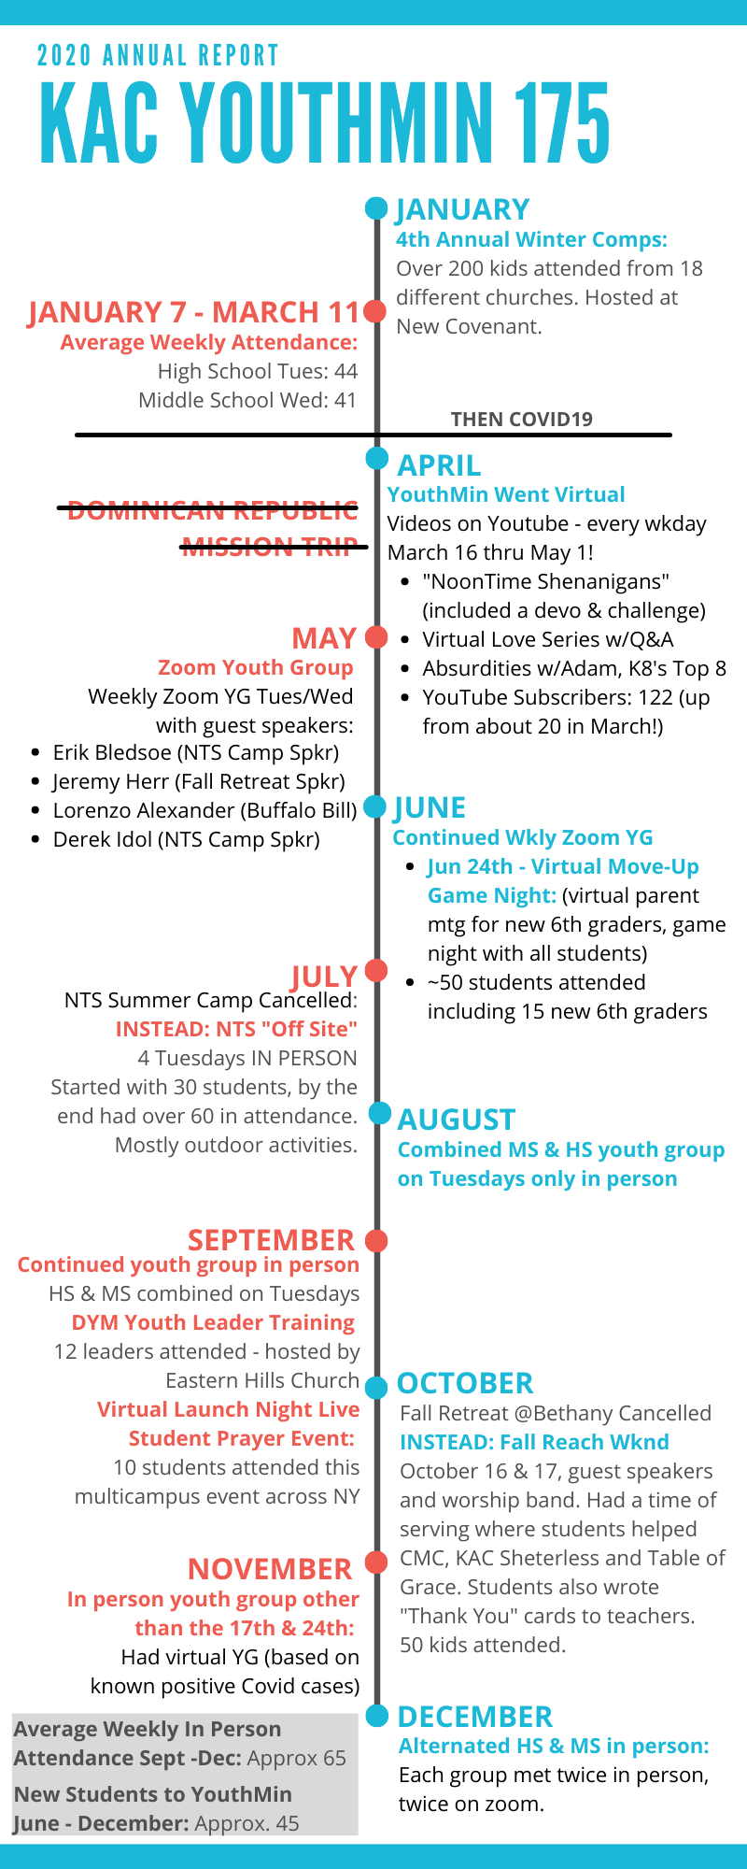
2020 was full of pain, tragedy and difficulty. But God finds a way in the midst of it all to show his favor! Here are some of the wins and stories of our youth ministry this year:

Winter Comps: Winter Comps is a collaborative night with other local churches intended for our students to see that the body of Christ is bigger than just our church. Over 200 students from 18 different churches attended this event hosted at New Covenant Church. Our largest event to date!

Leaders on Zoom: When things shut down in March, one of our HS leaders was burdened to stay. She purchased her own Zoom account to meet regularly with HS girls. This was a huge blessing to our students that were suffering with all the limitations on gatherings.

New students: With sports cancelled and after school activities limited, students were coming here because we were open! We have seen over 45 new faces since June! It has been a blessing to watch these once strangers become regulars and a part of our youth ministry family.

MS Worship team kids: The Middle School worship team has become a group where young, shy 6th-8th graders have really blossomed! 6 new kids have joined the team. It has been so fun to see these sweet kids desire to point people to Jesus through music.

Reach Weekend: Since we were not able to go away camping, we instead hosted a Friday night and all-day Saturday event that engaged our students spiritually and missional-ly. One student who recently started attending yg commented “it was best weekend of my life!” We had 50 students attend and it was a highlight of our fall.

College ministry: Spent the year discussing the Bible 2020 reading plan. We went virtual in March and ended up meeting 3 new people online before we met them in person! Our group is 6-8 people every week with numbers fluctuating when college students come back home!

Looking to 2021: So many things continue to be unknown as we hope for things to return to some state of normalcy but I can promise you that Kate and I are going to do the best we can to provide programs and opportunities for students to be discipled. Our youth ministry exists to glorify God my making disciples of Jesus Christ for a lifetime! We will do everything in our power to keep that going!
KidMin Annual Report 2020

KAC Kidz exists to partner with parents and families to make disciples for a lifetime.

Cancelled, moved, changed, postponed. No, let’s do Reinvented, New ideas, Growth and Blessings.

Reinvented: VBS and Fall Fest both needed BIG changes. Instead of bringing hundreds of people to our building, we sent kits home for families to disciple their kids and invite their neighbors into the process. This opened opportunities for people who wouldn’t walk into a church. They got to hear and see the gospel of Jesus lived out right in their own backyard (literally). Families worked together, grandparents invited grandkids and cousins lead little ones in Bible lessons and worship. We also partnered with Cornerstone Church which was great!

New ideas:
- At-Home boxes: The family has the single greatest spiritual impact on kids and we enjoyed coming along side that. This was well received. We underestimated the need every time!
- KidzChurch is a new spin on Sunday Mornings for elementary kids. They get to worship with their family and the body of Christ, then they enjoy an age-appropriate lesson. It’s a great balance that we are loving!
- CarePoints: There were several new opportunities for families to use the gym or drop kids off for childcare just to get a break. These were provided as a connection point and a chance for parents to rest a little.

Growth: Between recorded Bible lessons and no in-person contact with kids, we were stretched. Workers recorded lessons and worship songs for the kids. Teens helped with technology and editing. Small Group Leaders sent cards and notes to the kids. We even made home deliveries at Christmas for kids we haven’t seen in months. God certainly grew us as leaders and creative ministry thinkers. We were forced to look at the “why” and then figure out a new “how” for everything.

Hidden Blessings: 2020 was a challenge. But our glass is not half full; instead “my cup runs over.” (Psalm 23:5). We counted people, not numbers. God removed clutter so that we focused on Him more and programs less. I was blessed by the ways parents and families stepped up to engage their kids in real faith and discipleship. I was blessed by the parents picking up boxes and lingering for a conversation. I was blessed by the front porch talks, the little waves from the windows and the smiles from kids. God was SO good to us this year.

Goals for 2021:
- To safely resume ministries and kid community
- To continue to connect with and empower families to share their faith
- To support and train volunteers to use their gifts with kids

Thank you for partnering with us as we press on in Christ,

Carolyn Kiddy

Stepping Stones:
26 Families

VBS:
220 Kids

Fall Fest:
30 Families

Advent Boxes:
55 Families

KAC kids:
175



2020 Equipment Purchases, Repairs and Facility Projects
(Completed and Ongoing)
Item/Task Description | Date | Cost
Building maintenance and Tool Crib | 01/03/20 | 55.83
New Building – door stops | 01/04/20 | 45.42
(2) Trashcans, 5-tier shelf, (2) doorstops | 01/06/20 | 142.88
Emedco; New building parking signs | 01/08/20 | 24.32
Miscellaneous facility supplies | 01/10/20 | 19.59
Miscellaneous facility supplies | 01/13/20 | 31.33
Building maintenance & supplies | 01/13/20 | 74.45
Miscellaneous tools/hardware | 01/15/20 | 25.69
Building maintenance | 01/15/20 | 70.47
(2) Entrance rugs & woodscrews | 01/20/20 | 37.74
Harbor Freight; Equipment - 2.5 ton pallet jack | 01/21/20 | 223.99
Janitor room shelving, crib tools and hardware | 01/27/20 | 125.31
Harbor Freight; Maintenance workbench | 01/29/20 | 119.99
Tools and maintenance supplies | 02/01/20 | $66.87
Misc. building and grounds maintenance supplies;  (Handicap parking signs, stencils, hardware, etc.) | 02/20/20 to  02/25/20 | $271.63
Salt spreader and backstage motion light | 02/27/20 | $33.86
Handicap marking paint | 03/01/20 | $39.02
Enclosed trailer jack foot plate | 07/30/20 | $13.99
Building maintenance (paint rollers) | 08/04/20 | $21.98
Sign posts and H/C parking signs | 08/11/20 | $135.38
Access panel above new connector | 08/11/20 | $72.53
Cargo trailer; white exterior screws | 08/12/20 | $18.94
Cargo trailer; diamond plate chip guard | 08/12/20 | $97.88
Hardware for handicap signs | 08/17/20 | $6.44
Cargo trailer; aluminum edging & silicone caulk | 08/19/20 | $14.36
WS Enterprise; Phase II sealing and striping | 08/26/20 | $4,500.00
Padlocks; (3) trailer & storage container | 08/28/20 | $36.75
Access panel; lumber & mounting hardware | 08/31/20 | $13.09
Staging Dimensions; Stage wheels and skirting | 09/14/20 | $688.50
Home Depot; Materials for new baptistery staircase | 09/15/20 | $80.08
Miscellaneous; Building maintenance | 09/16/20 | $27.91
Miscellaneous; Baptistery staircase | 09/20/20 | $22.59
Sherwin-Williams; Baptistery stain | 09/22/20 | $102.38
Hand tools; Workshop | 09/24/20 | $55.51
Harbor Freight; Trailer side marker lights | 09/28/20 | $10.78
Handles for carrying Baptistery stairs | 09/29/20 | $9.16
Miscellaneous hardware | 10/02/20 | $16.44
Miscellaneous hardware | 10/03/20 | $11.82
Window cleaning supplies | 10/13/20 | $20.24
Home Depot; Blocking/plywood for baptistery | 10/21/20 | $41.93
Harbor Freight; Wheel chock (trailer) & transfer pump (baptistry) | 10/22/20 | $16.98
Home Depot; Shower door/Parsonage | 10/24/20 | $212.49
Home Depot; N.E. entrance hardware (CMC) | 10/28/20 | $14.51
Home Depot; Finishing products for baptistery | 10/29/20 | $97.15
American Floor Mats; Baptistry floor mats | 10/30/20 | $348.00
Valu; Touch up paint for old sanctuary chairs | 11/17/20 | $6.97
Parsonage; Replacement ground post for mailbox | 11/19/20 | $23.96
MJ Mechanical; Repair rooftop HVAC unit in Youth Bldg. | 11/19/20 | $636.76
Home Depot; Miscellaneous electrical supplies | 11/23/20 | $8.53
Harbor Freight; Tool crib – drill bits | 12/07/20 | $10.99
Home Depot; “C” batteries for motion lights | 12/08/20 | $26.68
McMaster-Carr; Max. clearance sign/miscellaneous supplies | 12/21/20 | $53.36
Buffalo Material Handling; Pallet racks for backstage area | 12/21/20 | $1,539.50
Valu; Numbers for Maximum clearance sign | 12/23/20 | $3.56
YTD TOTAL |  | $10,426.51

Respectfully,
Bob C Barden
Facilities Manager
2020 Elder Report- Dave Barden, Vice-Chairman

To achieve our mission, which is to fulfill the Great Commission (Matt.28:18-20), we ran into some challenges due to the pandemic in 2020. Our new reality reminded me of a Marine Corps slogan that coincides with a similar approach and shared perspective of words to live by during this time. That saying was, “Adapt, Improvise and Overcome.” “Adapt” to the problems and unforeseen circumstances and after assessing the situation and developing an actionable plan, we then “improvised” with the tools and resources at hand as we set a clear path forward to “overcome” these obstacles with resilience and fortitude. To accomplish our purpose of “connect, grow and serve,” it required the Spiritual giftedness and commitment of all of God’s people. However, I would be remiss if I did not give special recognition to all of the staff at Kenmore Alliance Church for the extraordinary work it took to effectively Adapt, Improvise and Overcome. Praise and Glory be to God to whom this would not be possible.
The Charge
God’s Word exhorts us as elders “to keep watch over ourselves and all the flock of which the Holy Spirit has made us overseers and shepherds of His Church. This includes exhorting and admonishing the saints in sound doctrine by being committed to knowing and making known the Word of God by clearly teaching His Word so that it may be both learned and applied to our lives. This year all elders took part in sharing the teaching responsibilities of our adult Sunday school hour as we collectively read through the entire Bible together; although it must be noted that Bob Oursler did the lion’s share of the teaching. It was an informative and richly rewarding time spent both virtually and in person. I especially enjoyed the diversity in the teaching approaches.
Discipleship
All elders are committed to discipleship and working with a small groups of believers in a way that facilitates their spiritual growth, both at church and in home gatherings. The goal is to make disciples who in turn make disciples by learning how to teach others. Elders are also committed to investing time mentoring others to aid and encourage them in their spiritual growth and journey as believers.
Prayer and Servanthood
As elders we are committed to prayer as we meet every Saturday morning to pray for the people and ministries of Kenmore Alliance Church, but also committed to public and private prayer with others. Elders are also servant leaders and must therefore be willing to live an exemplary life-style by ministering to the people at KAC. Each elder is expected to fulfill an area of responsibility assigned to him. The following are those areas of responsibilities: Deacons & communion steward-Paul Keleher; Ministry Board-Jeff Spencer; Facilities-Paul Stark; Secretary-Brian Baney; Prayer-Al Fast; Benevolence-Dave Barden. Our newest elder Jeff Spencer, fit right into our diversified group and got out of the gate running. His legal background helped to make him a valuable asset on the committees for revising our Bylaws and Benevolent Policies. He is responsible for organizing an outdoor Chapel program at Faun Lake, a community camp with trailers and cabins. He is also part of an organized team that is responsible for a WNY Christian mediation program. Elder Paul Stark is continuing to be a part of serving women, mostly widows, with the oil change ministry, a service offered free of charge. In addition, he continues to have oversight of the “Free Indeed’ program. Paul Keleher and Dr. Fast have had ongoing opportunities to be a blessing to others as they pray and share their faith in their respective mission field…the hospital. This past year Dr. Fast has prayed with a colleague along with several patients to receive Christ, some of whom were on their death bed. I have on occasion the opportunity to speak at funerals and bring a message of salvation and was able to do so this past year. It is, I believe, one of the greatest open doors to evangelize and share what is the hope, beyond the grave, of one who is puts their trust and faith in Jesus Christ.
While 2020 was a little different, some of the elders visit shut-ins, make hospital visits, and assist those who are troubled. We also are able to dispense or serve communion when desired. Marriage counseling is also available by some of the elders and their spouses.

Benevolence
Part of the elder oversight is in the administration of the grace of benevolence. It is designed to help regular attendees and people connected to the KAC family during a time of crisis to help with lodging, food, medical treatment, transportation to and from a place of employment, and funeral expenses. In Acts Chapter 4 it says that all believers were one in heart and mind. There were no needy persons among them because those who counted themselves blessed by God gave of their assets to be distributed to anyone who had need. In Proverbs 19:17 it states “He who is generous to the poor lends to the Lord, and He will repay him for his good deed.” Also, “He who gives to the poor will never want, but he who shuts his eyes will have many curses.” (Prov.28:27) Someone once said, “What you do for yourself dies with you, but what you do for others goes before you.” To those members and adherents at KAC, your generosity and love for your brethren is being evidenced through your giving, it also shows the love of God that abides in you. This year we received $ 33,850 in donations and distributed $ 12,338 among God’s people at KAC.
Membership
All those who have completed a membership class and have either been baptized or signed up for baptism are required to meet with an elder for an interview and to review their application. This has several purposes among them being that you agree to KAC doctrinal statement dictated by God’s Word. That you are willing to hold yourself accountable under elder leadership, and that you are willing to serve and support KAC and its ministries. This year we interviewed and accepted into membership 5 new people. This was by far the lowest number we have had in years, obviously due to the pandemic.
Pastoral Leadership Care
Though stated in the elder job description we, the elders, are committed to the spiritual well-being of the pastoral staff. An elder is to pray for, encourage and exhort the pastors of the church. Along with the entire elder board, he is to hold pastors accountable for their spiritual journey and ministries within the church. In our recent leadership retreat one of the 2021 initiatives was to develop a care team that would look to have assistance in place for staff, elders and their spouses in the event of special needs that may come as a result of their ministry to the church. This has yet to be defined or worked out.
In conclusion, I would like to echo what so many of the elders that I serve with have stated; “it is a great privilege to serve God and His people with some of the godliest men that I know.” We are a group of elders with diverse personalities with a desire to hear from God and know His perfect will. Our desires is to be of one accord even as the Father and the Son are one. Sometimes we may not always agree, but we will always conclude with a consensus and maintain that bond of peace between us. If you don’t already, consider praying for your elders on a regular basis, that we would live a life of obedience and holiness to God without reproach.

In His Service,
The Elder Board,
Al Fast, Brian Baney, Dave Barden, Paul Keleher, Bob Oursler, Jeff Spencer and Paul Stark

ANNUAL DEACON REPORT 2020

2020 was a very different year (as you may have guessed) for the Deacons of KAC. We are used to serving the church body at KAC, and not being able to do that was difficult for us. The following report is a list of ministries and activities our deacons were able to be involved in prior to shutdowns and then as things gradually reopened were able to be involved in once again. We welcomed Dave Wendt and Rick Herritt as new deacons for 2021! Our deacons for 2021 in addition to Rick and Dave are Steve Roy, Joe Brown, Chad Heidelberger, Ken Swanekamp, Steve Westberg, Paul Horvath, Rob Pusateri, Gerry Soto, Larry Scaglione, Nick Francoforte, Carl Bampton, and Gary Stanton. Jerry Robson stepped down after many years of service as a deacon as well as serving as head of the Deacons. We all look forward to serving the body of Christ at Kenmore Alliance Church in the upcoming year.

VARIOUS MINISTRIES DEACONS SERVED IN DURING 2020
● Red carpet cafe (greeters, set up etc.…)
● Clothe me co-op
● Men’s ministry (meal prep)
● Ushering
● Serving communion
● Stage / Worship set up
● Numerous Small group / bible study facilitators
● Home & Hospital visitation
● Table of Grace
● Counting team
● KAC Camping team
● Ministry Board, Expansion committee
● Organize and set up the now annual 5k run
● Parenting / Marriage ministry involvement
● Prison ministry visitation.
● Shelterless ministry
● Oil change ministry
● Accountability/mentoring/discipleship
● Ministry board
● Worship ministry tech
● Outreach to Muslims
● Basketball ministry
● Various projects such as helping people move, advising on home repairs and breaking down and set up of the sanctuary for different events.

So as you can see from the above list (pandemic or not) as a group and individuals we do stay busy in and outside of Kenmore Alliance Church. In 2020 we did not have Funday or the annual 5K which are 2 of our larger outreach events. We also spend much time in prayer for the congregation and our elders.

In closing, deacons are called to be committed to God, our families, Kenmore Alliance Church, one another, SERVANTHOOD, discipleship and evangelism. If EVER you should need to talk to any of us, need help with something or have a prayer need please see any of us, WE ARE CALLED TO SERVE!

DEACONESSES’ REPORT 2020

We started out strong, but much of our ministry changed drastically around the middle of March.
We enthusiastically anticipated the opening of the new sanctuary, and attended several meeting to discuss logistics, and hosted a Dedication Service on February 1, and an Open House on February 29. Several Deaconesses assisted with monthly communion in the old sanctuary, as well as the new sanctuary. Then COVID happened! Since March, we have been involved in individual ministry, and our theme could well be "bloom where you are planted". Below are some of the ministries our members have been involved in:
- Housekeeping in the kitchen following a mouse invasion
- Youth group assistance
- KAC serves, including Table of Grace, serving approximately 150 people per month
- Participation in and leading Women’s' Bible studies
- Hosting Backyard VBS
- Providing meals for various Meal Trains
- Helping at Clothe Me Coop
- Writing generic encouragement notes to be used by Clothe Me Coop
- Calls and notes of encouragement for church members and shut-ins.
- Continuation where possible with D Groups
- Prayer meetings and sharing of prayer concerns.
- Greeting and assisting at reduced capacity services at church

Mary Lou Francoforte represented the deaconesses on the KAC Ministry Board and was in regular communication with the chair and the Deaconesses.

Lisa Scaglione chaired the board for 2020 and will continue until we can once again meet and discuss succession.

Heather Garcia, Maria DeWyer, Gail Stark and Lani Knapp have stepped down from the board for a season, and Sherry Roy will be joining us for 2021.

On behalf of the Deaconesses,
Lisa Scaglione

From: Austin Miller, Treasurer
Kenmore Alliance Church
175 Bonnett Avenue, NY 14150-6847

Date: January 16, 2021

RE: KENMORE ALLIANCE CHURCH 2021 ANNUAL REPORT

Kenmore Alliance Church (KAC) enters 2021 on solid financial footing due to God's blessings and provisions in 2020.
As a result of significant expense reductions during the COVID shutdown, actual GF expenses were 86% of plan, while actual General Fund (GF) donations exceeded the plan by 3.2%. Excluding other funds, the GF cash balance grew by $150k during 2020. In context however, donations to the Building and Missions funds fell significantly. In response, the Ministry Board moved $27k from the GF to cover our commitments to the Great Commission.
The General Fund holds $523k, including $150k in an emergency fund, $97k in a contingent fund, $43k for planned expenses. The operating cash balance is $223k.
Construction of a new sanctuary began in mid-2019 with an expected cost of $2.6M. Starting with the first loan draw, KAC made interest-only payments on the outstanding principal. The total construction cost is estimated at $2.4M. The ADF finalized the mortgage on Sept 1, 2020 with starting balance of $1.2M and monthly payment of $8,020.
Services in the new sanctuary started on March 1, 2020 as planned. The COVID shutdown and subsequent restrictions severely curtailed in-person attendance. However, online attendance remains promising.

DESCRIPTION OF KAC FUNDS
- General Fund - Supports all the ministries and operating expenses of Kenmore Alliance Church
- Building Fund - Established for the expansion of Kenmore Alliance facilities

Specials – Funds designated by the Ministry Board to support special ministries or events
- Great Commission Fund - All income for this fund goes to the C&MA National Office on a monthly basis for use in the furthering of the gospel worldwide. KAC donations contribute directly to missionaries in Russia and Jordan.
- Local Missions Fund - Supports evangelistic and other (non-CMA) ministries in the KAC area of influence. The KAC Ministry Board determines which ministries receive support.
- Benevolent Fund – Administered by the Elder Board to help people in need.

Giving and expenses for these funds are summarized in the table on the next page.

Please contact the Treasurer any financial questions concerning Kenmore Alliance Church.

regarding
Austin Miller
Treasurer

KAC ANNUAL STATEMENT FOR 2020

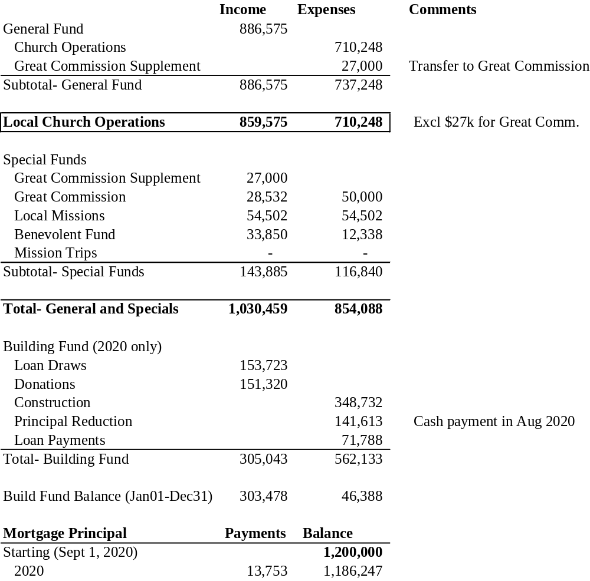

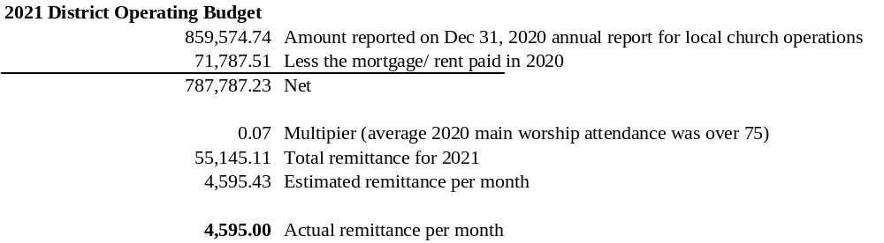
MEMBERS KENMORE ALLIANCE CHURCH 10/9/20

- ACCARDI, SARA
- ALLEN, LARRY
- BALON, KATE
- BAMPTON, CARL
- BAMPTON, MARIA
- BANEY, BRIAN
- BANEY, JENNIFER
- BARDEN, DAVID
- BARDEN, KAREN
- BARDEN, ROBERT
- BARDEN, ROBIN
- BARDEN, ROBERT II
- BARDEN, DEBRA
- BECK, DAVID
- BECKER, CASEY
- BEHRNS, GARY
- BEHRNS, NANCY
- BERRY, KAREN
- BERRY, RALPH
- BEVELOCK, PETER
- BEVELOCK, DONNA
- BLAIN, JOHN
- BLAIN, KAREN
- BOSTAPH, DAVE
- BOSTAPH, RICK
- BOSTAPH, SUSAN
- BOWMAN, DAVID
- BOWMAN, DENA
- BRENON, ROBERT
- BROCK, CAROL
- BROCK, DONALD
- BRODNICKI, KIM *
- BRODNICKI, SYLVIA
- BROWN, JOHANNA
- BROWN, JOSEPH
- BUNCE, JOE
- BUNCE, MELISSA
- BYTTNER, ARMINDA
- BYTTNER, JEFF
- CAMP, ALLISON
- CAMP, JEFFREY
- CANESTARO, CHRIS
- CANESTARO, LEAH
- CAREY, JOANN *
- CHRISTIAN, EVANS
- CHRISTIAN, MELISSA
- CLARK, ROBERT *
- CLICK, BILL
- CLICK, DANIELLE
- COBURN, PHILIP
- COOPER, SARAH
- CORNFIELD, AMY
- CORNFIELD, DAVID
- CRISPIN, KIM
- CURREY, MARY
- DANWIN, KEVIN
- DEWYER, DENNIS
- DEWYER, MARIA
- DEWYER, THOMAS
- DOLIN, JEWEL
- DULAK, BRANDY
- DULAK, DREW
- DURANDETTO, MARTHA
- EDWARDS, TERESA
- ELSAESSER, ROBERT
- ELSAESSER, MARY
- EMERSON, WILLIAM
- ERB, JAMES
- ERB, JAN
- FAIRCLOUGH, CRAIG
- FAIRCLOUGH, LINDA
- FAST, ALFRED
- FAST, ELEONORE
- FAST, REBECCA
- FINNERAN, DANIEL
- FISCHER, ERICH
- FOX, DOUG
- FRANCOFORTE, NICK
- FRANCOFORTE, MARYLOU
- GABLE, GEORGE
- GABLE, GINA
- GARCIA, AMERICO, JR
- GARCIA, HEATHER
- GIANNI, SANDRA
- GOEDDERTZ, JEFFREY
- GOEDDERTZ, JESSICA
- GOLDSTEIN, JIM
- GOLDSTEIN, SALLY
- Goodband, Kim
- Goodband, Jeff
- GOSS, ELIZABETH
- GOSS, SHAWN
- GUIDO, CYNTHIA
- HAARMEYER, DAVID
- HAARMEYER, VALERIE
- HARRISON, JEANETTE *
- HAUENSTEIN, LINDA
- HAUG, CAREN
- HEIDELBERGER, CHAD
- HELLES, MICHELLE
- HENDERSON, CHRIS
- HENDERSON, REBECCA
- HERRITT, RICHARD
- HERRITT, TRICIA
- HOAGE, CATHY
- HOAGE, GEORGE
- HORVATH, PAUL
- HY, CHRISTI
- JONES, Charles
- JONES, Michelle
- KELEHER, PAUL
- KELEHER, TRACEY
- KENERSON, ED
- KENERSON, KATHY
- KIDDY, CAROLYN
- KIDDY, JON
- KINGSBURY, BETTY
- KINGSTON, DONNA
- KINGSTON, JACK
- KNAPP, LEILANI
- KONIDIS, ANNETTE *
- KONIDIS, JAMES *
- KORNACKI, JULIAN
- KORNACKI, NANCY
- KOTAK, JERI
- LANDES, DEBBIE
- LANDES, FORREST
- LANSON, GARY *
- LANSON, MARY *
- LENG, MINFEI
- LENG, LISA
- LIPSKI, CHRISTINA
- Manikowski, Dennis
- MANNING, SEAN
- MANSFIELD, JAN
- MANSFIELD, JOHN
- MARCY, WILL
- MCCAFFERY, SCOTT
- MCGOWAN, SARAH
- MILLER, AUSTIN
- MILLER, J. AUSTIN
- MILLER, JUDY
- MILLER, YUKIKO
- MONTAGNA, DONNA
- MONTAGNA, RICHARD
- MORELLO, DONNA *
- MUNOZ, SUSAN L.
- MUELLER, KARLEY
- NOLTEE, WILLIAM
- NOLTEE, MARLENE

- OURSLER, BOB
- OURSLER, NICOLE
- PATTERSON, JEAN
- PETKUS, MILDRED
- PIKUL, STANLEY
- POCZCIWINSKI, PATTY
- POCZCIWINSKI, TIM
- PRELL, BRIAN
- PRELL, CATHERINE
- PUSATERI, ROBERT
- PUSATERI, SHARON
- RAE, KATHLEEN
- REED, PATRICIA
- RENDE, STEVE
- RIPELLINO, KEVIN
- RIPELLINO, PAM
- ROBINSON, JAN
- ROBSON, DONNA
- ROBSON, GERARD
- ROSEBORO, KEITH
- ROY, SHERRY
- ROY, STEPHEN
- RUPP, KELLY
- RUSSELL, JENNIFER *
- SAKOVICS, ERIC
- SAKOVICS, NAOMI
- SCAGLIONE, LARRY
- SCAGLIONE, LISA
- SCARPENA, KATE
- SCHANLEY, DANIEL
- SCHANLEY, DAWN
- SCHLOSSIN, KRISTIE
- SCHLOSSIN, WES
- SCHUMMER, CRYSTAL
- SCHUMMER, MATTHEW
- SCHUTT, CHERYL
- SCHUTT, NATHAN
- SCHWARTZ, ANDREW
- SCHWARTZ, STEPHANIE
- SHAKKOUR, LOUIS
- SHERIDAN, JUDITH
- SIEJAK, SHIRLEY
- SIMPSON, RICHARD
- SIMPSON, DEBORAH
- SMITH, DAVID *
- SNIDER, BRIAN
- SNIDER, ROBIN
- SNYDER, BILLIE-JO
- SNYDER, RON

- SOTO, DON
- SOTO, GERRY
- SOTO, LOUANNE
- SOTO, STACEY
- SPENCER, JEFFREY
- SPENCER, MICHELLE
- SPENCER, VICTORIA
- STANTON, GARY
- STANTON, LINDA
- STARK, PAUL
- STARK, GAIL
- STEIN, TRACY
- SVENSSON, ERIK
- SVENSSON, SANDY
- SWANEKAMP, LINDA
- SWANEKAMP, KEN
- TEMPLE, DIANE
- TEMPLE, TODD
- TOLEDO, SUSANNA
- TOLNAY, DOLORES
- TRAINA, CAROL
- TRAINA, MARK
- VALVO, ELAINE *
- VESPA, JILLIAN
- VESPA, NICK
- VIRGA, JOEL
- VIRGA, MARIVANA
- WALKER, BRITTANY
- WALKER, DAVID
- WALSH, BILL
- WALSH, MICHELLE
- WEBSTER, RICHARD
- WEBSTER, SELMA
- WEISS, DON
- WEISS, TRACY
- WELLS, CARRIE
- WELLS, RON
- WENDT, DAVID
- WENDT, SUZANNE
- WESTBERG, LAURA
- WESTBERG, STEPHEN
- WHITING, JAMES
- WIESNET, ALLYSON
- WIESNET, JOE
- WILLIAMS, ADAM
- WILLIAMS, MOLLY
- YOUNG, TIM
- ZACH, JOSEPH
- ZACH, LAURA

INACTIVE
- BROCK, DENNIS
- D’AMICO, ROSE
- ISEMINGER, LAURA
- SMITH, AARON
- SMITH, PATRIZIA
- SMITH, PAULA
- YAGER, VIRGINIA

